ONLINE STORE SALES DATA ANALYTICS

TABLE OF CONTENTS

1. Executive Summary 2
2. Project Objectives 2
3. Tools and Technologies Used 3
4. Dataset Description 3
4.1 Dataset Overview 4
4.2 Dataset Summary 5
4.3 Revenue Calculation 5
5. Project Methodology 6
5.1 Data Loading 6
5.2 Data Cleaning 6
5.3 Revenue Calculation 6
5.4 Exploratory Data Analysis (EDA) 6
5.5 Data Visualization 7
5.6 SQL Analysis 7
5.7 Power BI Dashboard Development 7
6. Key Results 7
6.1 Overall Sales Performance 7
6.2 Major Findings 8
6.3 Summary 8
7. City-Wise Sales Analysis 9
8. Category-Wise Sales Analysis 10
9. Monthly Sales Analysis 12
10. SQL Analysis 14
11. Power BI Dashboard 15
12. Business Insights 16
13. Business Recommendations 16
14. Limitations 17
15. Conclusion 18

1. Executive Summary
The Online Store Sales Data Analytics project focuses on analyzing sales data to identify business trends, evaluate product performance, and support data-driven decision-making. The project uses a dataset containing 2,000 records with information about orders, dates, products, categories, cities, quantities, and prices.
Python libraries such as Pandas and Matplotlib were used for data cleaning, processing, analysis, and visualization. One record containing a missing Quantity value was removed, resulting in a cleaned dataset of 1,999 records. A Revenue column was created by multiplying Quantity by Price. SQL queries were used to analyze sales by product, city, category, and month. Power BI was used to develop an interactive dashboard presenting key performance indicators and sales patterns.
The analysis recorded a total revenue of 51,500,062, with laptops generating the highest revenue and chairs having the highest quantity sold. Ahmedabad was the highest-revenue city, while Electronics was the leading category. The findings were used to develop business insights and recommendations related to inventory management, product promotion, regional sales performance, and data quality.
Overall, this project demonstrates how Python, SQL, and Power BI can be combined to transform raw sales data into meaningful insights that help businesses understand performance and make informed decisions.

2. Project Objectives
The main objective of this project is to analyze online store sales data and extract meaningful insights that can help improve business performance.
The specific objectives are:
- To load and understand the online store sales dataset using Python.
- To identify and handle missing values and prepare clean data for analysis.
- To calculate total revenue and other important sales performance metrics.
- To identify the best-performing products, categories, cities, and months.
- To perform Exploratory Data Analysis (EDA) using Pandas and Matplotlib.
- To use SQL queries to retrieve and analyze sales information.
- To create an interactive Power BI dashboard for visualizing sales performance.
- To derive business insights and provide recommendations based on the analysis.

3. Tools and Technologies Used
The following tools and technologies were used to perform data cleaning, analysis, visualization, and reporting in this project.
- Python: Used as the primary programming language for data processing and analysis.
- Pandas: Used to load, clean, manipulate, and analyze the sales dataset.
- Matplotlib: Used to create charts for visualizing city-wise, category-wise, and monthly sales performance.
- Jupyter Notebook: Used to write and execute Python code and document the analysis process.
- SQL (SQLite): Used to retrieve and analyze sales information through SQL queries.
- Power BI: Used to create an interactive dashboard containing key performance indicators, charts, and a city slicer.
- CSV and Excel: Used for storing, viewing, and handling the sales dataset.

4. Dataset Description
The dataset used in this project is an Online Store Sales dataset containing information about customer orders, products, sales quantities, prices, and locations. It was analyzed to understand sales performance and identify useful business insights.
The original dataset contained 2,000 records and 7 columns. During data cleaning, one record with a missing Quantity value was removed, resulting in a final cleaned dataset of 1,999 records. A new column named Revenue was added to calculate the revenue generated by each order record.

4.1 Dataset Overview
S. No. | Column Name | Description
1 | Order_ID | Unique identifier for each order
2 | Date | Date of the order
3 | Product | Name of the product sold
4 | Category | Category to which the product belongs
5 | City | City where the order was recorded
6 | Quantity | Number of units sold
7 | Price | Price per unit of the product
8 | Revenue | Revenue calculated from quantity and price

4.2 Dataset Summary
Attribute | Details
Dataset Name | Online Store Sales
Original Number of Records | 2,000
Original Number of Columns | 7
Missing Values Identified | 1
Records After Cleaning | 1,999
Final Number of Columns | 8
File Format | CSV

4.3 Revenue Calculation

A new column named Revenue was created to calculate the revenue generated by each record.
Formula:
Revenue = Quantity × Price
This calculated column was used to analyze total revenue, product performance, category performance, city-wise sales, and monthly sales trends.

5. Project Methodology
The project was carried out through a systematic process involving data loading, data cleaning, revenue calculation, exploratory data analysis, data visualization, SQL analysis, and dashboard development. Each stage helped transform the raw sales dataset into meaningful information for business decision-making.

5.1 Data Loading
The sales dataset was imported into Python using the Pandas library. The dataset was loaded from a CSV file into a DataFrame, allowing the records and columns to be examined. The initial structure, number of records, column names, and data types were checked to understand the dataset before performing further analysis.

5.2 Data Cleaning
The dataset was examined for missing values and data inconsistencies. One record containing a missing value in the Quantity column was identified and removed. The Date column was converted into the appropriate date format to support time-based analysis. After cleaning, the dataset contained 1,999 records and was used for further analysis.

5.3 Revenue Calculation
A new column named Revenue was created to calculate the revenue generated by each record. Revenue was calculated by multiplying Quantity by Price. This column helped measure total revenue and compare the performance of products, categories, cities, and months.
Formula:
Revenue = Quantity × Price

5.4 Exploratory Data Analysis (EDA)
Exploratory Data Analysis was performed using Pandas to identify patterns and trends in the sales data. The analysis focused on product performance, city-wise revenue, category-wise revenue, and monthly sales. Summary statistics and grouped results were used to identify the best-performing areas of the business.

5.5 Data Visualization
Matplotlib was used to create visual representations of the analyzed data. A bar chart was created to compare revenue across cities, a pie chart was used to show category-wise revenue distribution, and a line chart was used to examine monthly revenue trends. These visualizations made the results easier to understand and interpret.

5.6 SQL Analysis
SQLite was used to perform additional analysis through SQL queries. Queries were executed to calculate revenue by product, city, and category, analyze monthly revenue, and identify the top five products by quantity sold. The query results provided an additional way to examine the dataset and validate key findings.

5.7 Power BI Dashboard Development
Power BI was used to develop an interactive sales dashboard based on the cleaned dataset. The dashboard included key performance indicator cards, product revenue analysis, category-wise revenue distribution, city-wise performance, a quantity-versus-revenue scatter chart, monthly revenue analysis, and a city slicer. These elements helped present the findings in a clear and interactive format.

6. Key Results
The analysis of the cleaned online store sales dataset produced several important results regarding revenue, product performance, city-wise sales, category performance, and monthly trends.

6.1 Overall Sales Performance
Metric | Result
Total Revenue | 51,500,062
Total Orders | 1,999
Average Order Value | 25,762.91
Records Analyzed | 1,999

6.2 Major Findings
- Highest Revenue Product: Laptop generated the highest revenue of 27,105,144.
- Highest Quantity Sold: Chair was the top-selling product by quantity, with 568 units sold.
- Best-Performing City: Ahmedabad recorded the highest city-wise revenue of 7,449,911.
- Leading Product Category: Electronics generated the highest category revenue of 37,093,350.
- Highest-Revenue Complete Month: December 2025 recorded the highest monthly revenue of 4,891,185 among the complete months analyzed.
- Lowest-Revenue Complete Month: June 2025 recorded the lowest monthly revenue of 3,654,206 among the complete months analyzed.

6.3 Summary
The results show that laptops contributed substantially to revenue, while chairs recorded the highest sales quantity. Electronics was the leading category, and Ahmedabad was the strongest city in terms of revenue. Monthly analysis highlighted variations in sales performance throughout 2025. These findings provide a foundation for the detailed analysis and business recommendations presented in the following sections.
Note: January 2026 contains data for only one day and was excluded from the comparison of complete months.

7. City-Wise Sales Analysis
City-wise sales analysis was performed to compare revenue across the eight cities in the dataset.
City | Total Revenue
Ahmedabad | 7,449,911
Delhi | 7,092,644
Kolkata | 6,819,173
Mumbai | 6,702,803
Hyderabad | 6,565,333
Chennai | 5,944,069
Pune | 5,764,738
Bangalore | 5,161,391
Ahmedabad generated the highest revenue, while Bangalore generated the lowest. These results help compare regional sales performance and identify opportunities for further investigation.
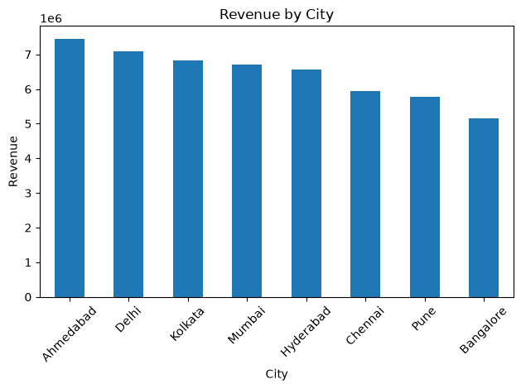
Figure 7.1: Revenue by City

8. Category-Wise Sales Analysis
Category-wise sales analysis was performed to compare the revenue generated by different product categories. The results showed that Electronics generated the highest revenue, followed by Furniture, Accessories, and Stationery.
S.No | Category | Total Revenue
1 | Electronics | 37,093,350
2 | Furniture | 13,343,784
3 | Accessories | 905,769
4 | Stationery | 157,159
Electronics contributed the most revenue among the four categories, while Stationery contributed the least. These findings help identify the leading product category and support category-wise sales planning.
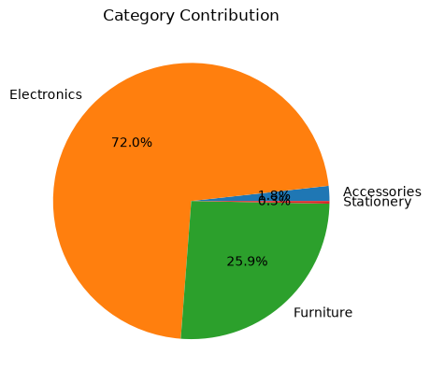

Figure 8.1: Category Contribution

9. Monthly Sales Analysis
Monthly sales analysis was performed to examine changes in revenue over time. The results showed that December 2025 recorded the highest revenue among the complete months, with 4,891,185, while June 2025 recorded the lowest, with 3,654,206.
Month | Total Revenue
January 2025 | 4,021,909
February 2025 | 3,655,339
March 2025 | 4,607,846
April 2025 | 4,783,602
May 2025 | 4,884,091
June 2025 | 3,654,206
July 2025 | 3,979,183
August 2025 | 4,012,286
September 2025 | 4,318,017
October 2025 | 4,428,577
November 2025 | 4,185,989
December 2025 | 4,891,185
The results indicate that monthly revenue fluctuated throughout 2025. January 2026 was excluded from this table because the dataset contains only one day's data for that month, making it unsuitable for comparison with complete months.
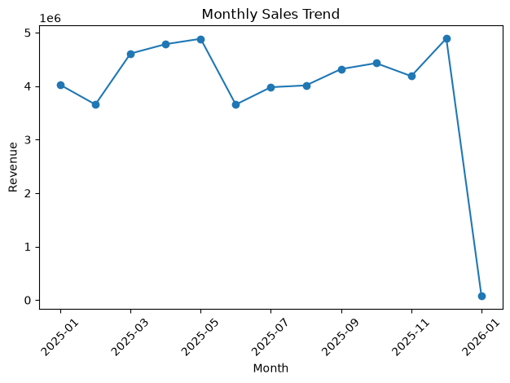
Figure 9.1: Monthly Sales Trend

10. SQL Analysis
SQL queries were executed using SQLite to analyze the cleaned sales dataset and obtain useful information about sales performance.
The following five queries were performed:
- Revenue by Product: Identified the total revenue generated by each product.
- Revenue by City: Compared total revenue across different cities.
- Revenue by Category: Analyzed revenue generated by each product category.
- Monthly Revenue: Examined revenue trends across different months.
- Top Five Products by Quantity Sold: Identified the five products with the highest sales quantities.
The SQL analysis provided additional insights into product performance, regional sales, category contributions, and monthly revenue trends.

11. Power BI Dashboard
Power BI was used to create an interactive dashboard to present the sales performance of the online store. The cleaned sales dataset was imported into Power BI, and different visualizations were created to summarize important business metrics.
The dashboard includes KPI cards for Total Revenue, Total Orders, Total Quantity Sold, and Average Order Value. It also contains a Revenue by Product bar chart, Category Contribution donut chart, City-Wise Revenue treemap, Quantity versus Revenue scatter chart, and Monthly Revenue waterfall chart. A City slicer was added to filter the dashboard by location.
The dashboard provides a clear overview of sales performance and allows users to explore the data through different visualizations and filters.
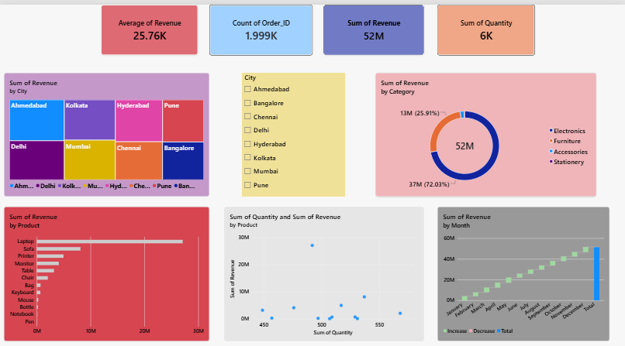
Figure 11.1: Power BI Sales Dashboard

12. Business Insights
The analysis of the online store sales dataset revealed the following key business insights:
- Product Performance: Laptop generated the highest revenue of 27,105,144, while Chair recorded the highest quantity sold, with 568 units.
- City Performance: Ahmedabad generated the highest city-wise revenue of 7,449,911.
- Category Performance: Electronics was the leading category, generating revenue of 37,093,350.
- Monthly Trends: December 2025 recorded the highest revenue among complete months, at 4,891,185, while June 2025 recorded the lowest, at 3,654,206.
- Data Quality: One record containing a missing Quantity value was removed during data cleaning. January 2026 contained only one day's data and was not directly comparable with complete months.

13. Business Recommendations
Based on the findings from the sales analysis, the following recommendations are suggested:
- Product Management: Monitor laptop sales and maintain suitable inventory levels for high-revenue products.
- Sales Promotion: Consider promoting chairs and related products to support sales volume.
- Regional Performance: Investigate the factors contributing to Ahmedabad's high revenue and identify opportunities to improve sales in other cities.
- Category Planning: Focus on the Electronics category while reviewing the performance of other categories.
- Sales Monitoring: Compare complete months when evaluating sales trends and ensure missing data is handled appropriately.

14. Limitations:
The analysis was based on the available sales dataset, which contains order details, products, categories, cities, quantities, prices, and dates. One record with a missing Quantity value was removed during data cleaning. January 2026 contained data for only one day, so it was excluded from the complete-month comparison. The dataset does not include costs or profit information, and the analysis cannot determine the exact reasons behind sales differences across products, cities, or months.

15. Conclusion:
This project analyzed online store sales data using Python, Pandas, Matplotlib, SQL, and Power BI. The analysis identified Laptop as the highest-revenue product, Chair as the top-selling product by quantity, Ahmedabad as the highest-revenue city, and Electronics as the leading category. Monthly sales trends and city-wise performance were also examined. SQL queries provided additional insights, while the Power BI dashboard presented key sales metrics through interactive visualizations. Overall, the project demonstrated how data analytics can transform raw sales data into meaningful business insights and practical recommendations.

SUBMITTED BY
S. Jeeva Mirudula

